Reference Screenshots:

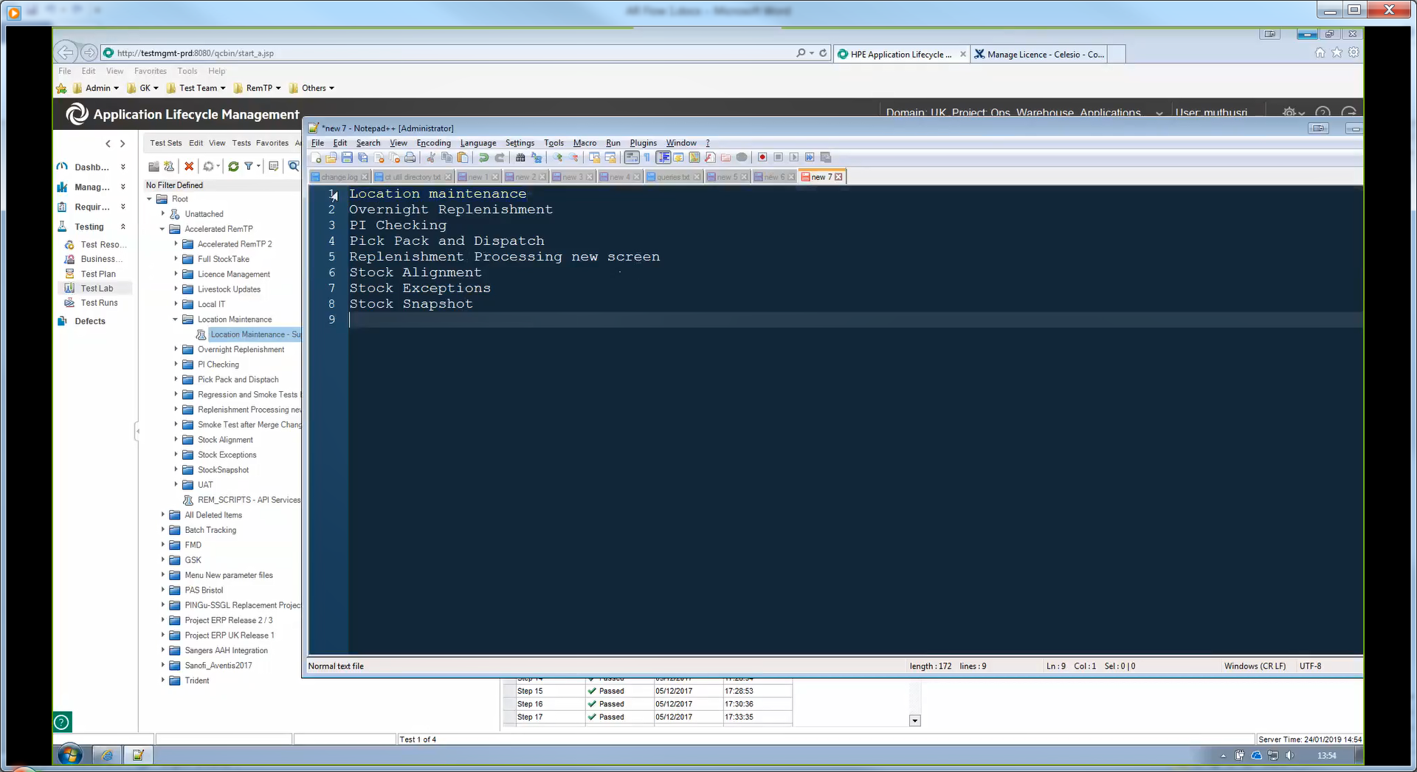

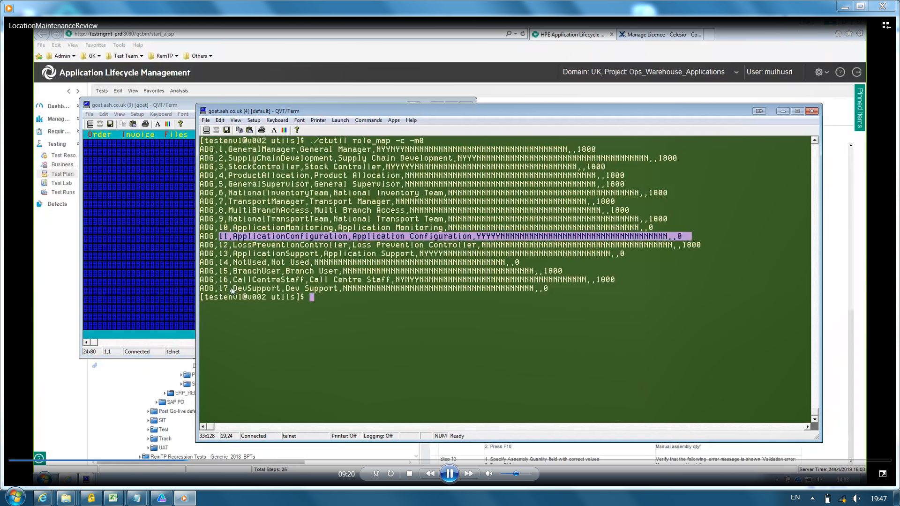

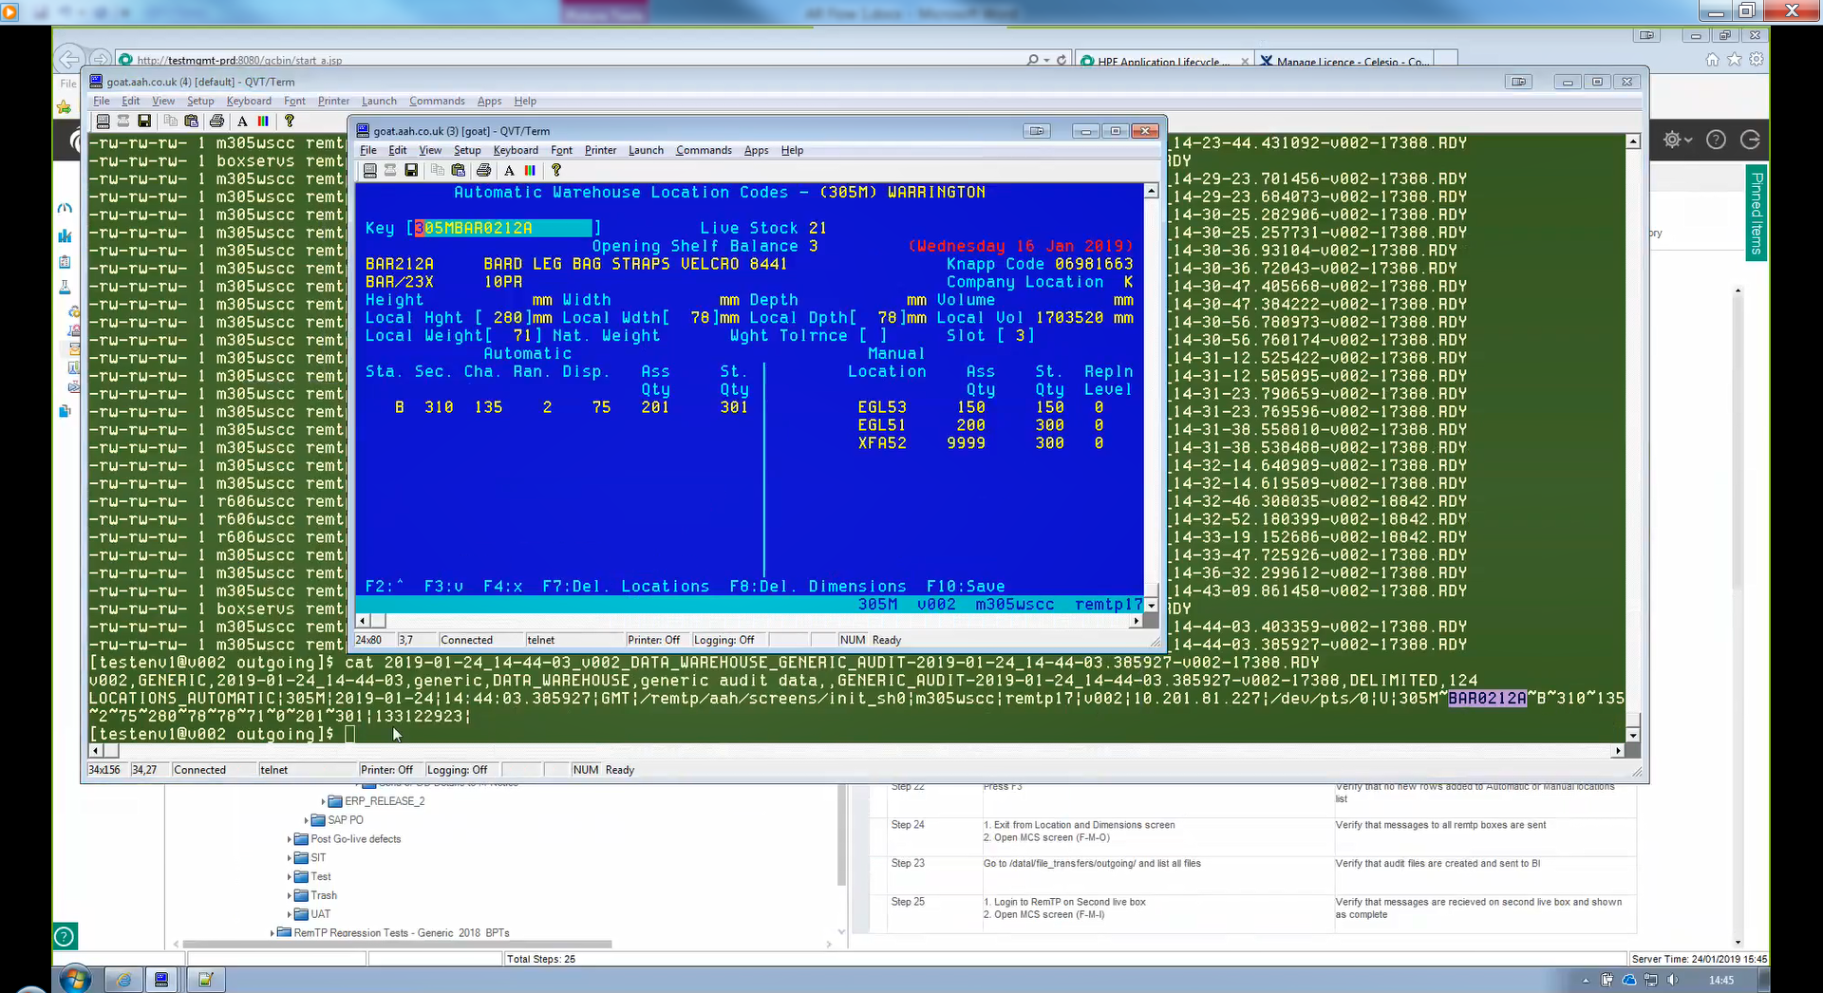

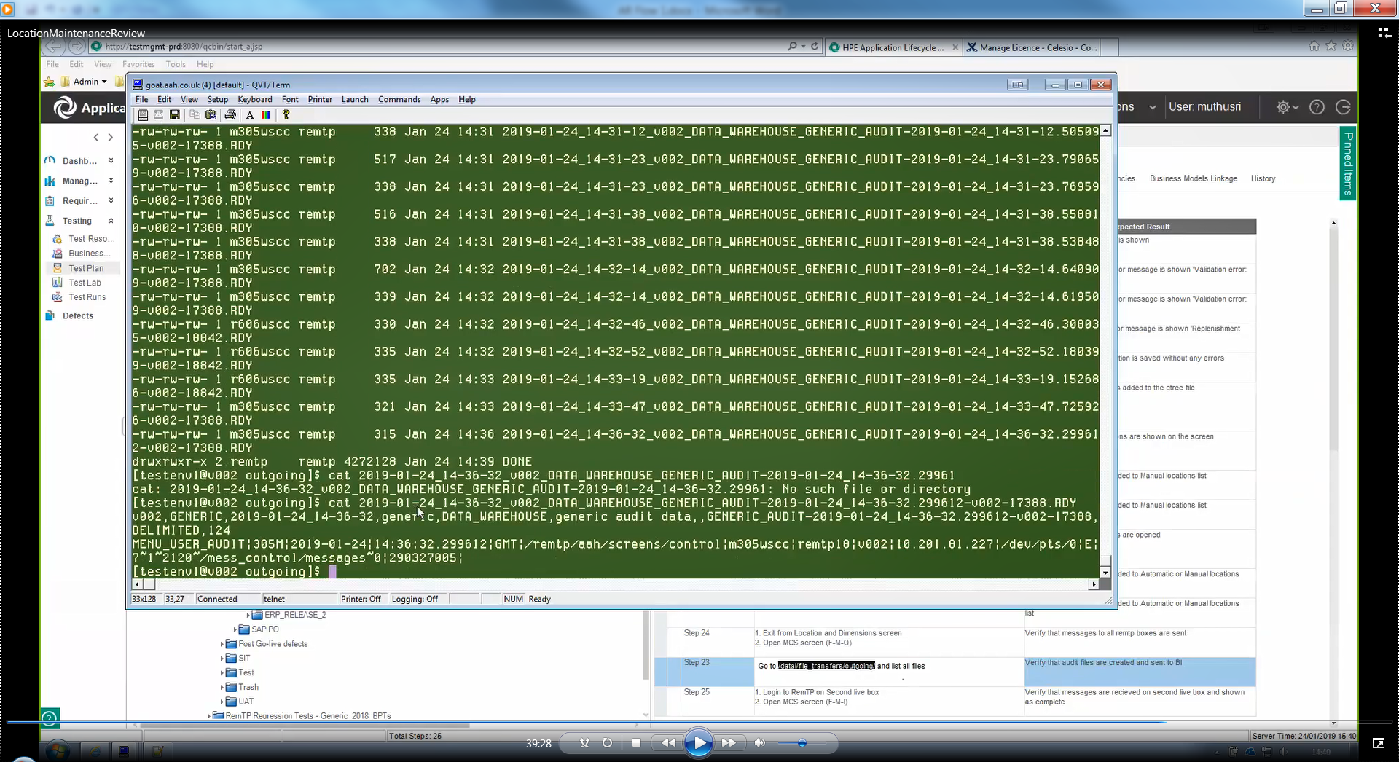

|  |  |  |
| --- | --- | --- |
| **Step Name** | **Description** | **Expected Result** |
| Step 20 | 1. Enter Key Code 305MBAR0212A to the Key field 2. Press Enter | Verify that dimentions details are opened |
| Step 21 | Press F2 | Verify that no new rows added to Automatic or Manual locations list |
| Step 22 | Press F3 | Verify that no new rows added to Automatic or Manual locations list |
| Step 24 | 1. Exit from Location and Dimensions screen 2. Open MCS screen (F-M-O) | Verify that messages to all remtp boxes are sent |
| Step 23 | Go to /datal/file_transfers/outgoing/ and list all files | Verify that audit files are created and sent to BI |
| Step 25 | 1. Login to RemTP on Second live box 2. Open MCS screen (F-M-I) | Verify that messages are recieved on second live box and shown as complete |

Environment 7

Front end : 305 M ( 20)

Login as Admin User to get

1. Login as User1 at branch 001B

2. Go to  Administration-> Data Maintenance->Locations & Dimensions screen

To get Data Maintenance window enable login as Admin user

Go to Quit -> Cntrled Access

UserID : remtp17

Pwd: Sapphire1

** To validate which User has what acess

Open another terminal:

7

29 ( for backend

5 ( for backend for v002 305M)

Go to cd /remtp/aah/utils/

Type Pwd to cross check Present working directory

/remtp/aah/utils

Command to pull role map

./ctutil role_map -c -m0

2. Go to  Administration-> Data Maintenance->Locations & Dimensions screen

Give the value 305MBAR0212A

./ctutil locations -k305M,BAR -c -g branch,code,man_0.area,man_0.aisle,man_0.bay,man_0.shelf,man_0.channel,man_0.warehouse_locn_6 -m10

./ctutil locations -k305M,BAR -v -g branch,code,man_0.area,man_0.aisle,man_0.bay,man_0.shelf,man_0.channel,man_0.warehouse_locn_6 -m10

./ctutil locations -k305M, BAR0212A -v -g branch,code,man_0.area,man_0.aisle,man_0.bay,man_0.shelf,man_0.channel,man_0.warehouse_locn_6 -m10

./ctutil locations -k305M, BAR0212A -v -g branch,code,man_0.area,man_0.aisle,man_0.bay,man_0.shelf,man_0.channel,man_0.warehouse_locn_6 -m10 | less

Whole set :

./ctutil locations -k305M, BAR0212A -v branch,code,man_0.area,man_0.aisle,man_0.bay,man_0.shelf,man_0.channel,man_0.warehouse_locn_6 -m10 | less

Press q to come out of command line

./ctutil locations -k305M -qman_0.area#Null -q'autom_0.station_no#' -q'autom_0.station_no#Null' -c -g branch,code,autom_0.station_no,man_0.area,man_1.area -m10

305MAAA0196G

./ctutil locations -k305M -qman_0.area#Null -q'autom_0.station_no#' -q'autom_0.station_no#Null' -v -g branch,code,autom_0.station_no,man_0.area,man_1.area -m10 -qcode=AAA0196G

I2 autom_0.range 1

C autom_0.filler . (0)

C autom_0.station_no B (66)

U4 autom_0.dispense_type 51

U4 autom_0.sector_rack 311

U4 autom_0.channel_posn 127

U4 autom_0.assembly_quant 6

U4 autom_0.storage_quant 27

I2 autom_1.range 0

C autom_0.station_no B (66)

U4 autom_0.sector_rack 311

U4 autom_0.channel_posn 127

I2 autom_0.range 1

U4 autom_0.dispense_type 51

U4 autom_0.assembly_quant 6

U4 autom_0.storage_quant 27

Go on to Manual Location

Press F2